|  |  |
| --- | --- |
| Course Name | ITD 2313 – Script Programming |
| Instructor | Michael Schnell |
| Student Name | Samantha Ramsey |
| Due date | 1/15/2023 |
| Grade | Put grade earned here |
| Grading Comments | Put instructor comments here |

# Page 33

## Project # 1

### Special Instructions:

1. This project may be done in the interactive python window.  No specific code file needs to be written for this project.  Screen shots do need to show the results for all 6 of the expressions.

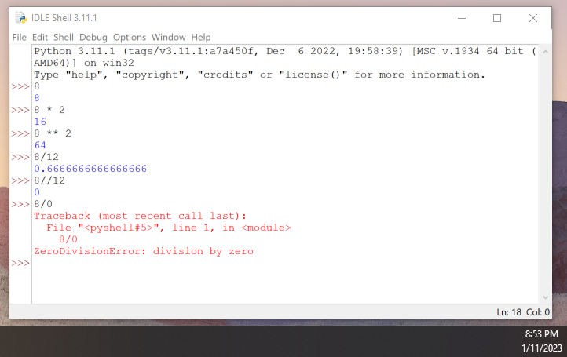

## Project # 2

### Special Instructions:

1. This project does require you write a python program.  Submit that python program as part of your submission zip file.  Call the program Project2-YourLastName

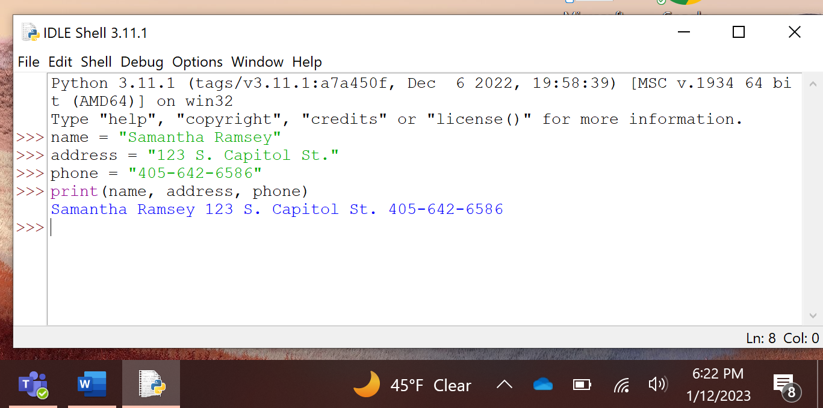

## Project # 3

### Special Instructions:

1. This project is done in the interactive python window.
2. Specific Test data:

* In the instructions where is says to assign name an appropriate value.  Assign name the value of Pistol Pete.

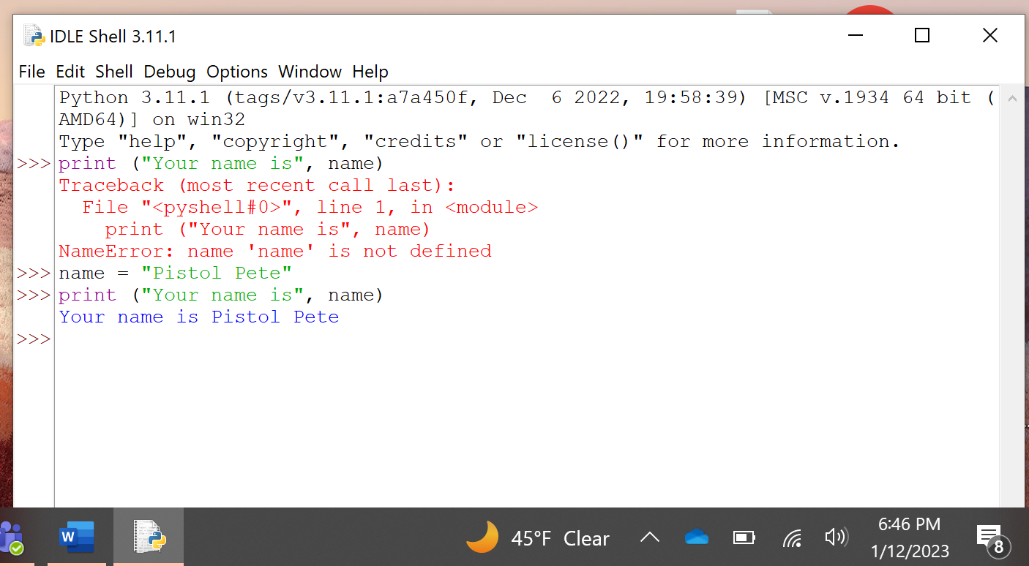

## Project # 4

### Special Instructions:

* 1. This project does require you to create a python program file.  Be sure to include that file in the zip file when submitting the assignment.
  2. Specific Test data:
* Instructions say to run it 3 times.  As it is a rectangle, your three test data sets are:
  + Run 1 - Length 10  Width 3

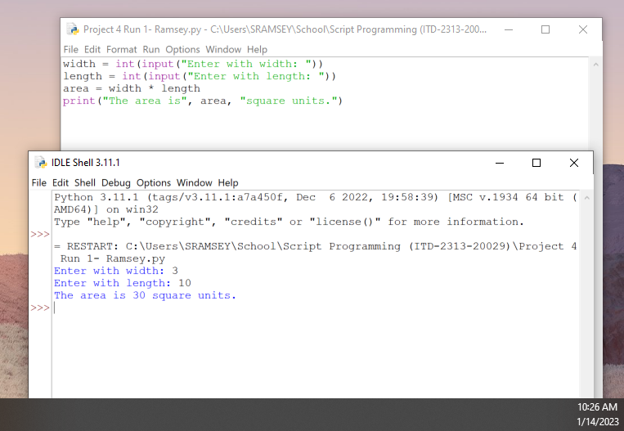

* + Run 2 - Length 7 Width 13

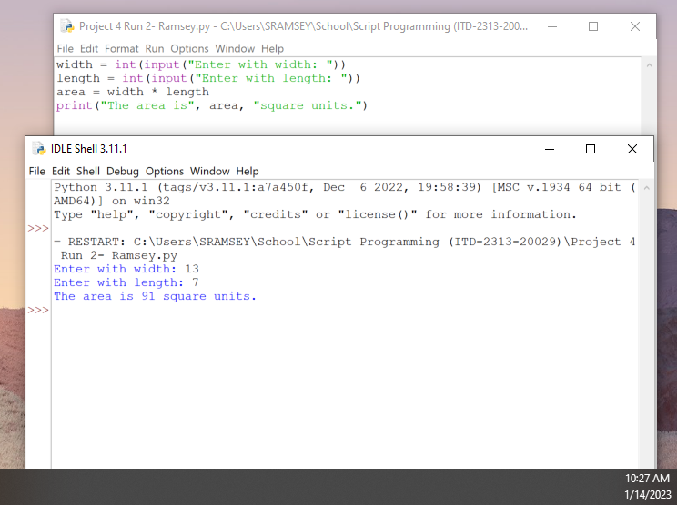

* + Run 3 - Length 6 Width 6

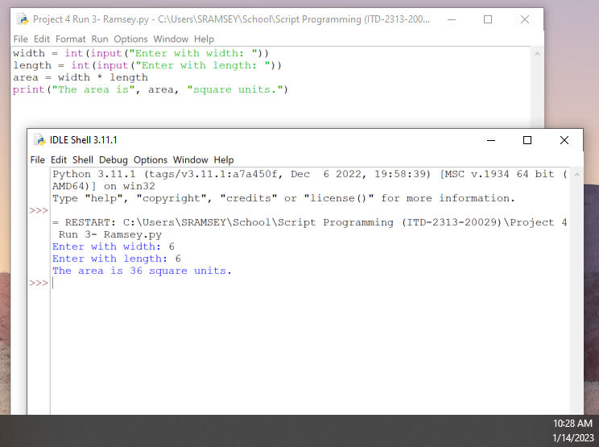

## Project # 5

### Special Instructions:

* + 1. This project requires that you write a python program.  Be Sure to include that file in the zip file when submitting the assignment.
* Specific Test data:
* You are to run this one 3 times also.  Use the following Base and Height pairs for those three runs.
* Run 1 - Base 5 Height 7

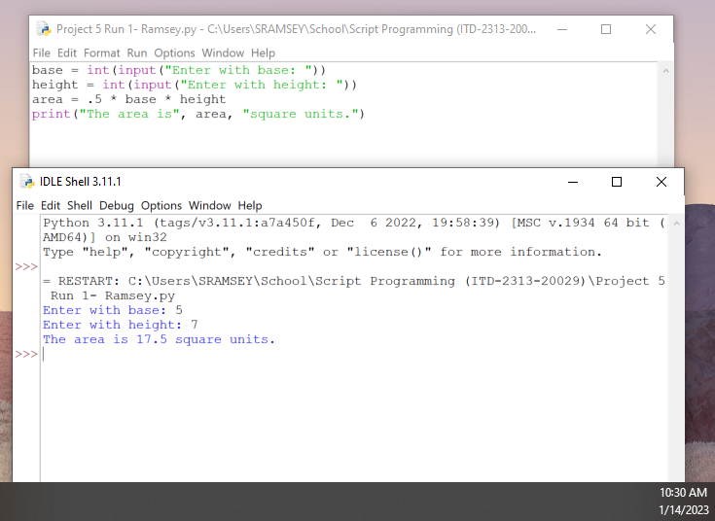

* Run 2 - Base 6 Height 5

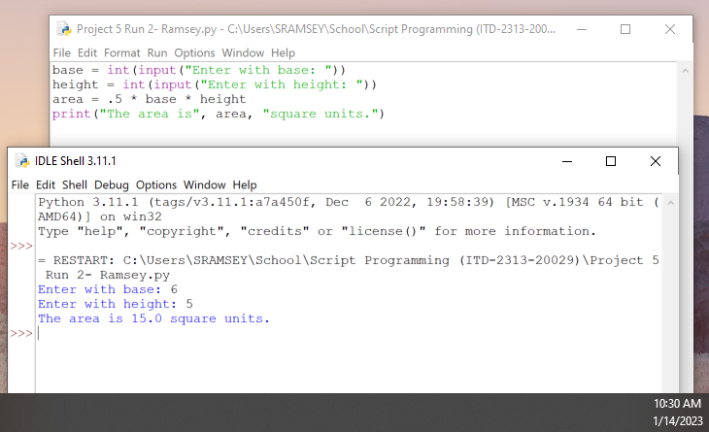

* Run 3 - Base 10 Height 10

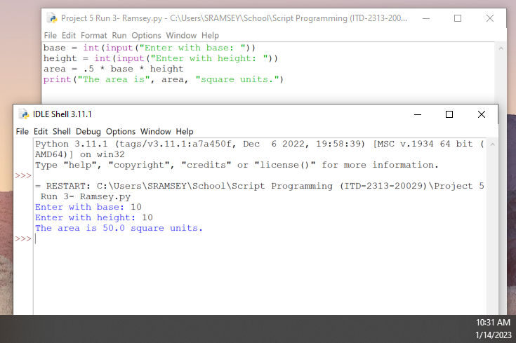

## Project # 6

### Special Instructions:

* + 1. This project requires that you write a python program.  Be Sure to include that file in the zip file when submitting the assignment.
* Specific Test data:
* You are to run this one 3 times also.  Use the following values for Radius in each of the runs:  Run 1 - 7,

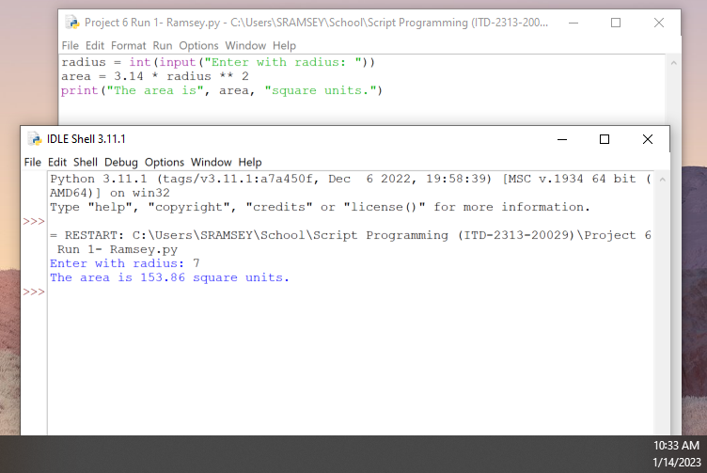

* Run 2 - 6.31,

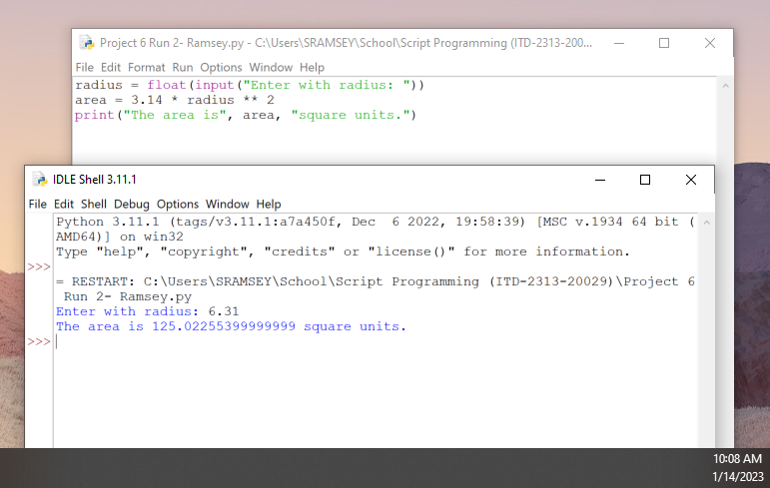

* Run 3 14.96.

